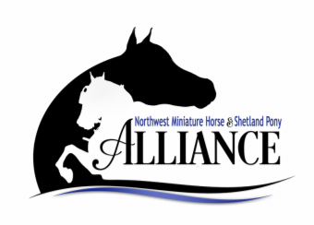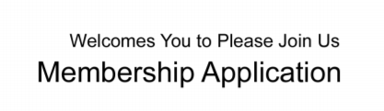

NEW:_____ RENEWAL:_____ ANNUAL MEMBERSHIP FEES: YOUTH--$5 INDIVIDUAL--$30 FAMILY--$50

DATE:____________________________ MEMBERSHIP YEAR:__________________________________

NAMES(S):____________________________________________________________________________

Youth (UNDER 18 YRS):_______________________________________DOB:_______________________

FARM NAME:__________________________________________________________________________

ADDRESS:_____________________________________________________________________________

CITY STATE ZIP:________________________________________________________________________

EMAIL ADDRESS:______________________________________________PHONE:___________________

How would you prefer your correspondence regarding club matter?

Email:___________ Phone:______________

Website:______________________________________________________________________________

I may have interest in the following Club activities and/or committees—Circle Show, Youth, Publications, Marketing/Advertising, Website, Education, Bylaws, Rules, Special Projects, Parades, ADS, Fun Events Other:______________.

I would like to Sponsor the 2024 NWMHSPA Show.

_________________Yes ________________No Which Class?___________________________________

Class Sponsorships are $45.00 per class and Champion or Grand Classes are $75.00.

I (we) have read the Bylaws of the NWMHSPA and any amendments hereafter, and agree to abide by those Bylaws and decisions made by the Executive Board pertaining the acceptance or termination of my (our) membership.

Signature (s) Date